Element Data Sheet Template
Production Company: |  | Project Title: | Set Extension
VFX Supervisor: |  | Location: | Headingley Campus Acre

Scene No: |  | Element No: |  | FX# |  | Date Shot: | 15/10/18
EXT/INT: |  | Day/Night: | Day | Format: |  | Aspect Ratio:

Camera Survey
Camera Info  Camera Motion: | Lens Info | Misc.
  Camera: | Cannon 700D
  FPS: | 60
   | Locked |  | Crane
  x | Pan/Tilt |  | Steadicam
   | Dolly |  | Handheld
  Tilt | 0°
  Make: | Cannon
  Focal Length: | 24mm
  F-Stop: | 5.6
  Focus (start): | 45
  Focus (end): | 45
  Height: | 140cm
  Filter: | n/a
  Time: | 4:30pm
  Sun angle: | 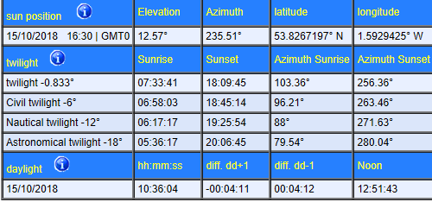

Set Survey
